- ATIVIDADE DE CASA
- INGLÊS
- 8º ANO
- DE 04 A 08 DE MAIO
- PROFESSOR ALEXANDRE

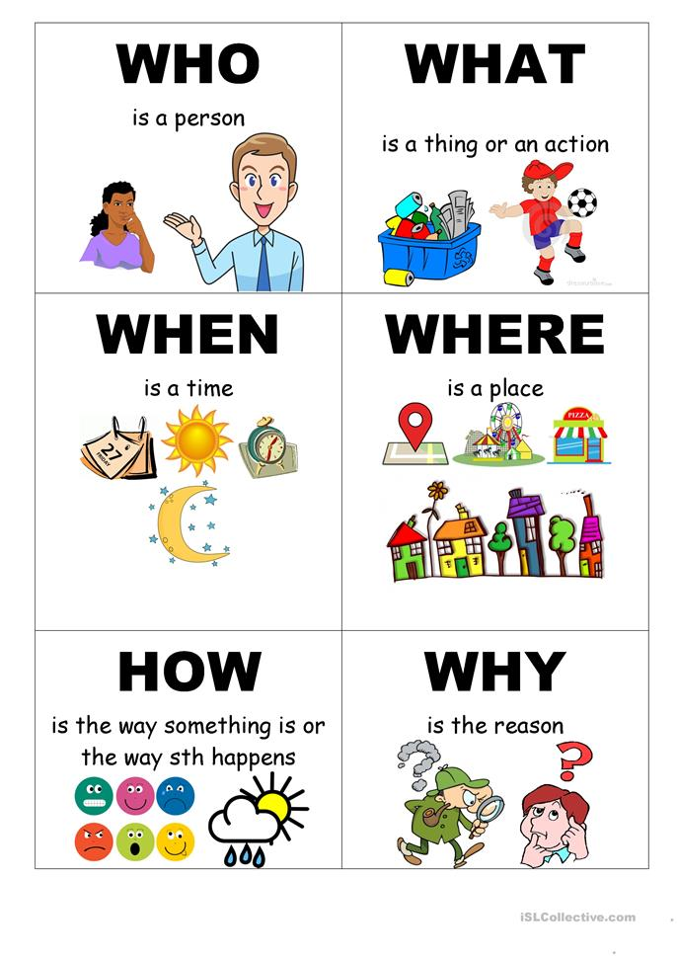
- PASSE PARA O PORTUGUÊS:

- WHO IS MIGUEL SERAFIM? HE IS A POLITICIAN.
- WHAT IS MERCURY? IT IS A PLANET.
- WHEN IS THE CARNIVAL? IT´S FEBRUARY.
- WHERE IS RIO DE JANEIRO CITY? IT´S IN BRAZIL.
- WHY TO STUDY GEOGRAPHY? BECAUSE IT IS IMPORTANT

